CSA5159-CNS For Infrastructure Security

1. Write a program for Caesar cipher involves replacing each letter of the alphabet with the letter
standing k places further down the alphabet, for k in the range 1 through 25.

#include <stdio.h>
#include <string.h>

int main()
{
char text[100];
int k, i;

printf("Enter plaintext: ");
scanf("%s", text);

printf("Enter key (1-25): ");
scanf("%d", &k);

printf("Ciphertext: ");

for(i = 0; text[i] != '\0'; i++)
{
char ch = text[i];

if(ch >= 'A' && ch <= 'Z')
ch = ((ch - 'A' + k) % 26) + 'A';

else if(ch >= 'a' && ch <= 'z')
ch = ((ch - 'a' + k) % 26) + 'a';

printf("%c", ch);
}

printf("\n");
return 0;
}
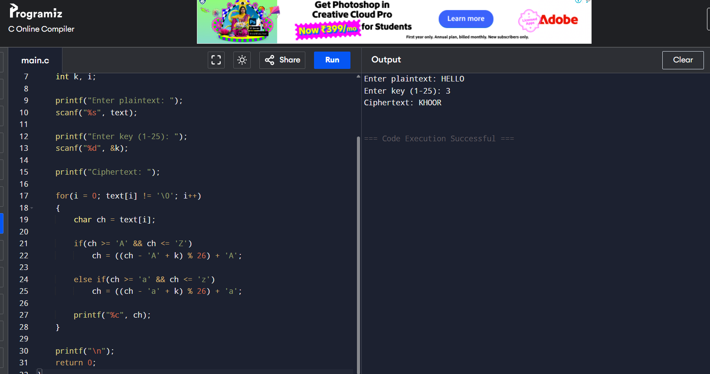

2. Write a program for monoalphabetic substitution cipher maps a plaintext alphabet to a ciphertext
alphabet, so that each letter of the plaintext alphabet maps to a single unique letter of the ciphertext
alphabet.

#include <stdio.h>
#include <string.h>
#include <ctype.h>

int main()
{
char plaintext[100], ciphertext[100];

// Substitution key
char key[] = "QWERTYUIOPASDFGHJKLZXCVBNM";

printf("Enter Plaintext: ");
scanf("%s", plaintext);

for(int i = 0; plaintext[i] != '\0'; i++)
{
char ch = toupper(plaintext[i]);

if(ch >= 'A' && ch <= 'Z')
ciphertext[i] = key[ch - 'A'];
else
ciphertext[i] = ch;
}

ciphertext[strlen(plaintext)] = '\0';

printf("Ciphertext: %s\n", ciphertext);

return 0;
}

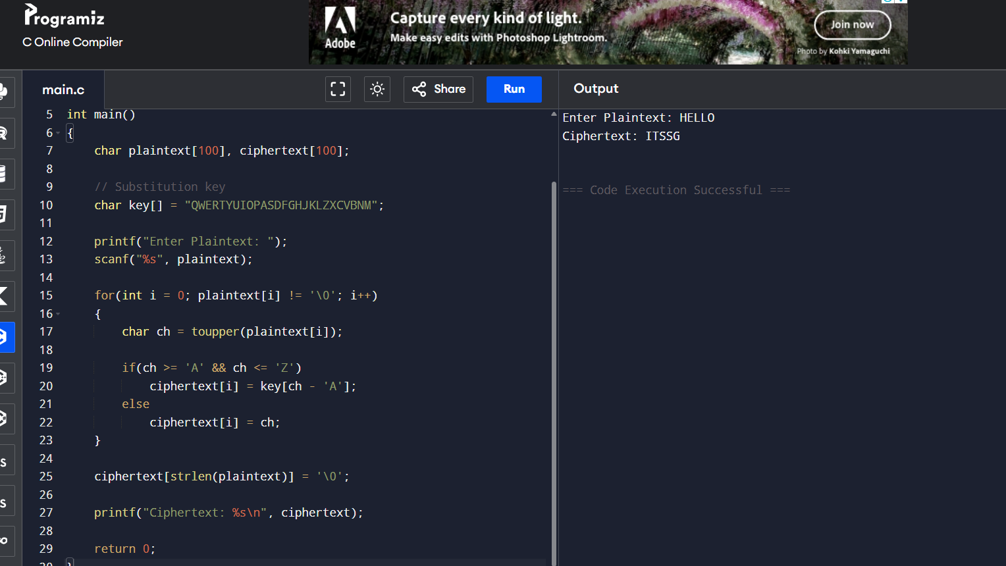
3. Write a C program for Playfair algorithm is based on the use of a 5 X 5 matrix of letters constructed
using a keyword. Plaintext is encrypted two letters at a time using this matrix.

#include <stdio.h>
#include <string.h>
#include <ctype.h>

char matrix[5][5];

// Function to generate Playfair matrix
void generateMatrix(char key[]) {
int used[26] = {0};
int row = 0, col = 0;

used['J' - 'A'] = 1; // I and J treated as same

for (int i = 0; key[i] != '\0'; i++) {
char ch = toupper(key[i]);

if (ch == 'J')
ch = 'I';

if (!used[ch - 'A']) {
matrix[row][col++] = ch;
used[ch - 'A'] = 1;

if (col == 5) {
row++;
col = 0;
}
}
}

for (char ch = 'A'; ch <= 'Z'; ch++) {
if (!used[ch - 'A']) {
matrix[row][col++] = ch;

if (col == 5) {
row++;
col = 0;
}
}
}
}

// Find position of character in matrix
void findPosition(char ch, int *row, int *col) {
if (ch == 'J')
ch = 'I';

for (int i = 0; i < 5; i++) {
for (int j = 0; j < 5; j++) {
if (matrix[i][j] == ch) {
*row = i;
*col = j;
return;
}
}
}
}

// Encrypt plaintext
void encrypt(char text[]) {
int len = strlen(text);

printf("\nEncrypted Text: ");

for (int i = 0; i < len; i += 2) {
char a = toupper(text[i]);
char b = toupper(text[i + 1]);

int r1, c1, r2, c2;

findPosition(a, &r1, &c1);
findPosition(b, &r2, &c2);

if (r1 == r2) {
printf("%c%c",
matrix[r1][(c1 + 1) % 5],
matrix[r2][(c2 + 1) % 5]);
}
else if (c1 == c2) {
printf("%c%c",
matrix[(r1 + 1) % 5][c1],
matrix[(r2 + 1) % 5][c2]);
}
else {
printf("%c%c",
matrix[r1][c2],
matrix[r2][c1]);
}
}
}

int main() {
char key[50], text[100];

printf("Enter Keyword: ");
scanf("%s", key);

printf("Enter Plaintext (even length): ");
scanf("%s", text);

generateMatrix(key);

printf("\nPlayfair Matrix:\n");
for (int i = 0; i < 5; i++) {
for (int j = 0; j < 5; j++)
printf("%c ", matrix[i][j]);
printf("\n");
}

encrypt(text);

return 0;
}

